International Conference on
Sudurpaschim Studies: Heritage, Innovation and Transformation
12-13 December 2022
Mahendranagar, Nepal
Organised by:
Far Western University, Nepal (सुदूरपश्चिम विश्वविद्यालय, नेपाल)
Co-organised by:
DSD Project, Institute of Social and Cultural Anthropology, Oxford University, UK
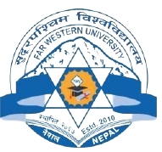
Britain-Nepal Academic Council, UK


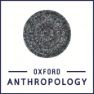

Abstract Submission Format
Title of the paper
Author(s)

Author’s affiliation

Contact details of presenting author(s) | Tel:  Email:
Abstract text (maximum 300 words)
Please indicate your preferred presentation format: | - Oral presentation with PowerPoint [ ]  - Oral presentation without PowerPoint [ ]  - Poster presentation [ ]  - Film presentation [ ]  - No preference [ ]

